**Assignment #5**

**Introduction to Linux**

**Ammad Ali**

**Task 1:**

Her Majesty has sent James '007' Bond on a secret mission to retrieve a missing nuclear weapon. 007 has the intel that weapon will be sold at a party on December 15 from 7 PM to 9 PM. Q has given 007 a watch which has custom Ubuntu OS having a script 'We_Are_Listening.py' to record audio via watch. Now 007 is at the party but his watch has encountered an issue. It can only record 2 minutes continuously. Write a cronjob so that 007 can have the complete voice recording through his watch.

**Solution:**

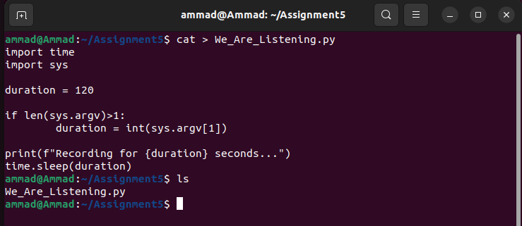

First of all, I created a python file that was going to be used for recording for 2 minutes. The python code was written in the file.

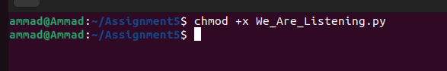

Then I gave permission to execute the file using chmod command

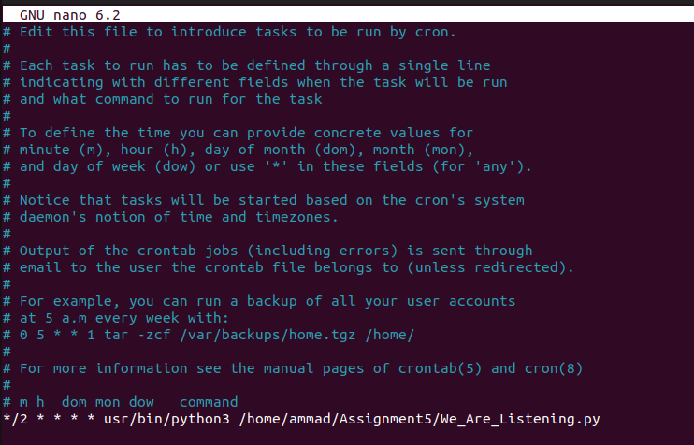

For testing purposes, I configured the crontab file in such a way that the python script ran every 2 minutes forever.

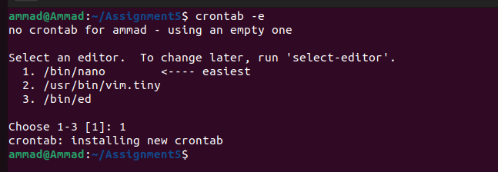

New crontab was created

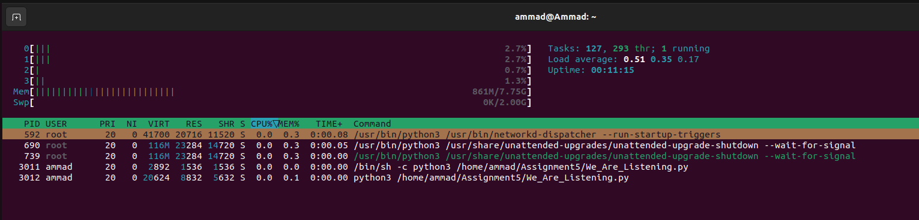

As we can see using the htop command, the file is running.

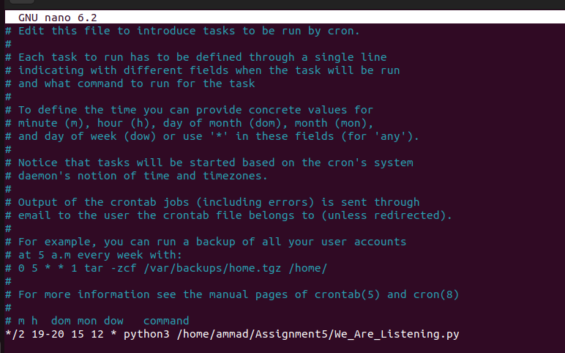

After that, I modified the cronjob file to the requirements that 007 wanted. Now the service will run every 2 minutes 7-9pm on 15th December.



The file was successfully updated

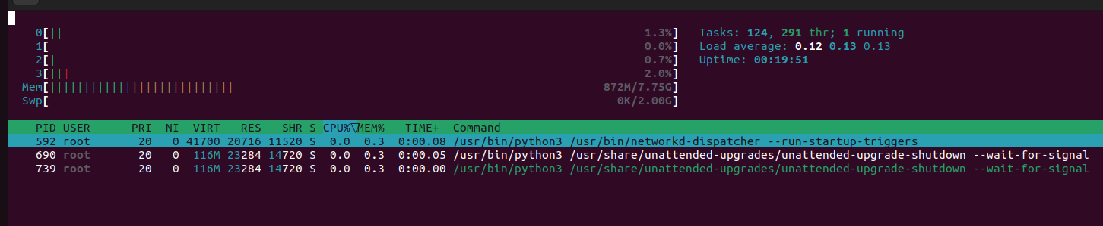

Now we can see that the python script isn’t running anymore. It will only run at the time that was set in the cronjob file.

**Task 2:**

Block the traffic from your friend’s machine coming towards your machine without notifying them.

**Solution:**

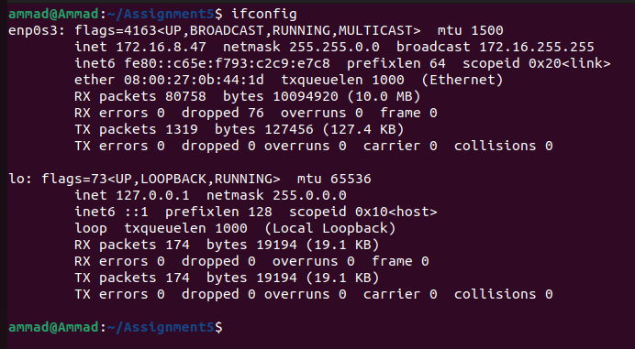

I used the ifconfig command to check my IP address. Before doing this, I had to set my VM Box adapter setting to bridged adapter to make sure the virtual machine was directly connected to our network (no NAT).

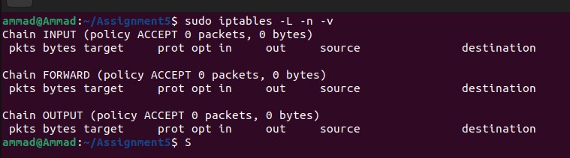

I then listed the IP tables. We can see that there are no rules set as of now.

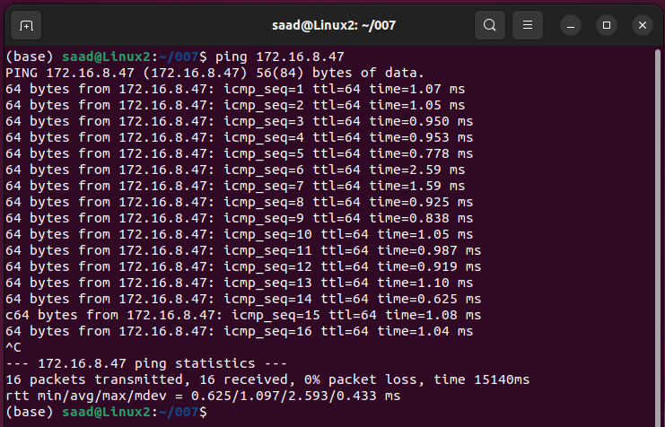’

I then asked a friend saad to ping my system using my IP and the packets were being sent.

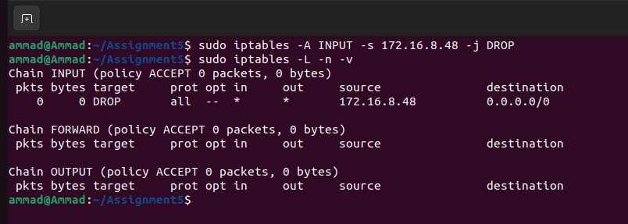

I then added a rule in IP table and gave my friend saad’s IP address. The job was set to drop every packet received from the IP 172.16.8.48 which was Saad’s IP.

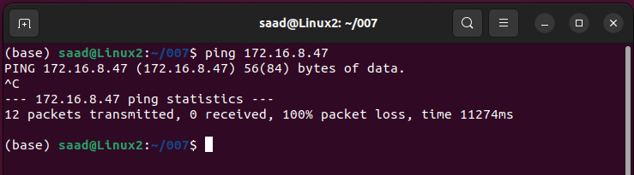

Now when Saad tried to ping me, all the packets were lost. The communication was successfully blocked.

**Task 3:**

Welcome to Money Heist, and Congratulations “Professor” has selected you to work for him from Pakistan. Professor has some files in the server hosted at IP address (your machine IP) but he wants to make a backup for this file because in case if he gets caught then state ministry will seize this server and all content will be erased. Professor is smart he knows if he keeps backup of the files then he will have leverage. Therefore, he has tasked you to copy the files from Server A hosted at (your machine IP) to Server B hosted at (your friend’s machine IP). Figure it out and help the Professor.

**Solution:**

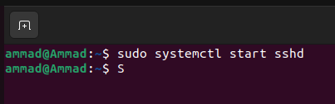

I started the SSH service on my system

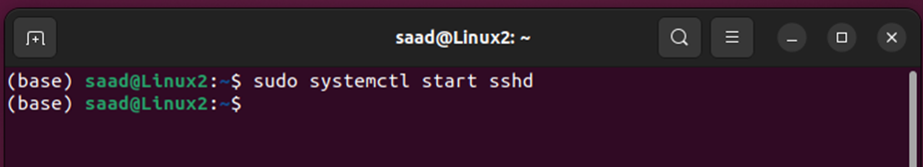

Saad started the SSH service on his system

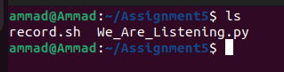

I wanted to back up the Assignment5 directory which had 2 files in it.

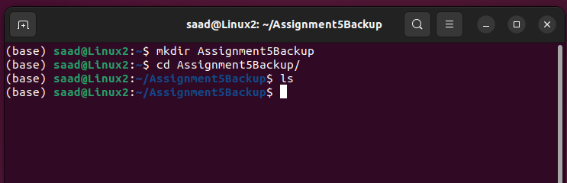

Saad created a directory in his system for my backup. This wasn’t necessary because rsync can create a directory if it is not present.

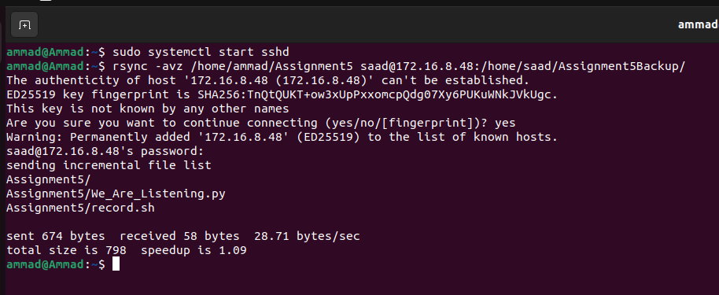

I then used rsync -avz command and gave the path of the directory I wanted to backup along with the path where I wanted to backup (which was a directory in Saad’s pc).

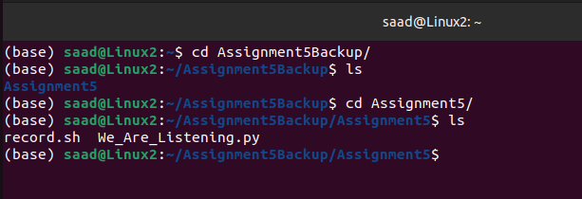

We can now see that the directory is backed up in Saad’s system.

**Task 4:**

Attention all Resistance Fighters in Star Wars! The fate of the galaxy rests on your shoulders, and the time has come for a critical mission. The Rebel Alliance is counting on your skills and teamwork to thwart the evil plans of Darth Vader and the Empire. You have been chosen to work closely with your fellow members in this daring operation. Your first task is to form pairs and create shared folders with each other. These shared folders will serve as your secret communication hubs, where you can exchange crucial intel and strategies to stay one step ahead of the dark side.  
Remember, this is a time for unity and solidarity. Your shared folders will be the backbone of your resistance efforts, and your collaboration will decide the fate of the galaxy. So gear up, embrace the Force, and show the Empire that the spirit of the Resistance is unbreakable. May the Force be with you all!

**Solution:**

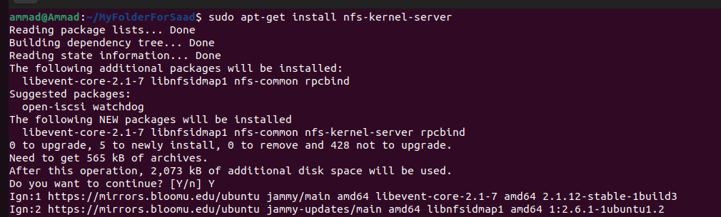

Installing nfs-kernel-server to act host a shared folder.

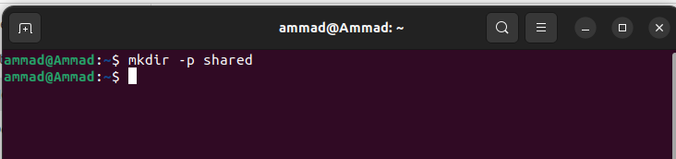

Created a directory named shared that will be shared.

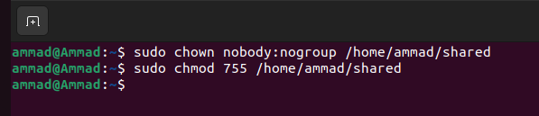

Changing the user and group ownership for the shared folder to nobody and no group. The permission commands executed again with 777 because I want everyone to have permission to perform all 3 tasks, read, write, and execute.



Giving read, write, execute permission to everyone

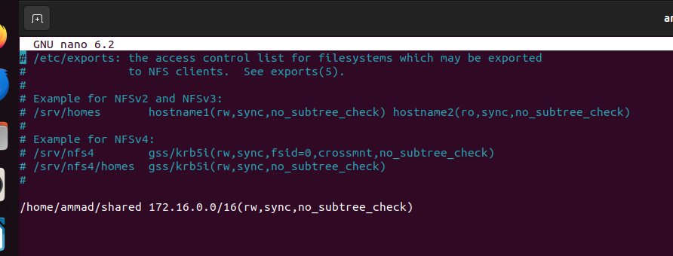

Editing the exports file created by nfs-server in the etc directory and providing the path of the shared folder.

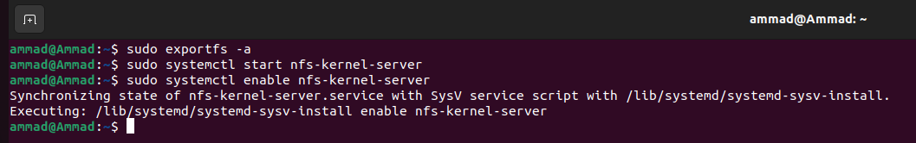

Starting the nfs-server for directory sharing.

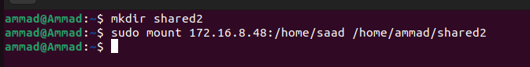

After starting the server, my shared folder was mounted with a folder created by saad on his system. Now that folder acts as the directory that will have the files that I will share.

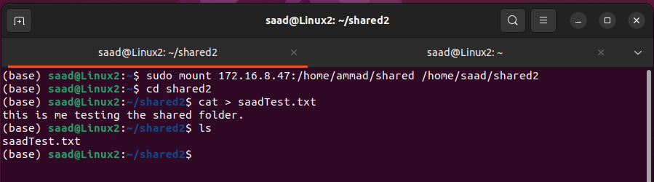

Now saad created a file in the shared folder and added some text in it.

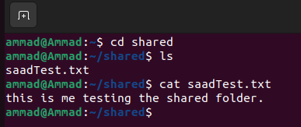

I can now access the shared file that was created by saad.